**KIYALA HIGH SCHOOL**

**S.1 THIRD TERM TEST**

**ITEM 1**

The District of Kampala is experiencing waves and waves of immigrants that enter the area day and night. The inhabitants of the district believe that just like the migration into East Africa between 1500 – 1800AD, these immigrants have pull and push factors that are causing their migration to the District.

**Task**

Make a write up that can be used to explain to the people of Kampala regarding the causes of the above event.

**Introduction**

Migration is the movement from one are to another just like the bantu, luo and Ngoni who migrated to east Africa between 1500 and 1800AD.

* These people are migrating from different places because of political, economic and social reasons.
* Some are migrating to Kampala in search for fertile soils for agriculture.
* Some are migrating to Kampala in search because they wanted to export new technology.
* The movement is due to population pressure in neighboring districts.
* Some are migrating to Kampala in due to internal conflicts like family quarrels in their cradle land.
* Some are migrating to Kampala in search due to external conflicts.
* Outbreak of Diseases like malaria, small pox, sleeping sickness and many other compelled people to migrate from their original land.
* Some are migrating to Kampala due to outbreak of floods in their districts.
* Hostile climate conditions like drought forced some to migrate to Kampala.
* Some are migrating to Kampala in search famine which has hit their districts.
* The some are migrating to Kampala in search to love of adventure and the desire to discover things beyond their districts.
* Some have moved to seek for employment opportunities.

Some are looking for better social services.

**(Any 10 will explained source = 10 scores)**

**Item 2**

One parent of a S.1 learner complained before the headteacher that although the government through National Curriculum Development Center (NCDC) reduced subjects done at O level, the subjects are still many on his small boy. The headteacher told him all the remaining subjects were left for a reason and that his boy was to benefit a lot. The parent rejected the head teacher’s argument and wondered how history and political education will benefit his boy. The headteacher called you as one of the S.1 learners to help the parent understand why history and political education was left on the O level subject menu

**Task:**

Write an essay of what you are going to tell the parent

**Expected responses**

**Introduction 02 scores**

1. The parent doesn’t know the values of studying history and political education and that’s why he is doubting whether his son can ever benefit from it
2. History and political education refer to the study of the past to appreciate the present and predict the future
3. It’s a subject that combines both history and political education
4. I would tell the parent the following as a way of convincing him that history and political education is a valuable subject

**Body 06 scores**

1. History provides important lessons from past mistakes and failures, enabling us to avoid repeating them in the future.
2. Studying history helps to preserve and promote cultural heritage, ensuring that the achievements and contributions of the past are remembered and celebrated.
3. Studying history and political education help individual’s separate facts from fiction and fight misinformation and propaganda found in many historical narratives
4. History and political education promote justice by raising awareness of past and present injustices and inequalities
5. History and political education promote global citizenship by promoting an understanding of international relations, global issues, and cultural diversity.
6. Studying history inspires leadership by providing examples of courageous leaders like Kabalega and Nyerere who made a positive impact on their societies.
7. It promotes peace by encouraging dialogue, reconciliation, and understanding between nations.
8. Studying history encourages critical thinking skills, as it requires analyzing evidence and evaluating arguments.
9. History and political education prepare students for participation in public life by equipping them with the necessary knowledge and skills for doing so.
10. Through the teaching of history and Political Education, learners are taught and made to know about their rights, duties and responsibilities in society
11. It helps us to create unity in diversity.

**Conclusion 01 score**

**NCDC left the subject on the subject menu because of the above political, social and economic reasons**

Consider any other conclusion deemed fit

**Scoring Rubric for item I**

|  |  |  |  |  |
| --- | --- | --- | --- | --- |
| 1 | The learner understands the pre-colonial history of East Africa | Provides focused relevant introduction | Learner should be able to;  Identify the problem in the scenario 01 score  Define the concept (history and political education) and give an example 01 score | 02 scores |
| 2 | - | Explains the advantages of studying history and political education to make the parent appreciate the subject and appreciate the work done by NCDC | Learner should be able to;   * Explain 6 and above points 6 scores * Explain 5 points 5 scores * 4 points 04 scores * Explain 3 points 03 scores * Explain 02 points 02 scores * Explain 1 point 01 score * No response 0 score | 06 scores |
| 3 | - | Conclusion | Learner gives a relevant conclusion in line with the task | 01 score |

**KIYALA HIGH SCHOOL**

**S.2 THIRD TERM TEST**

**ITEM 1**

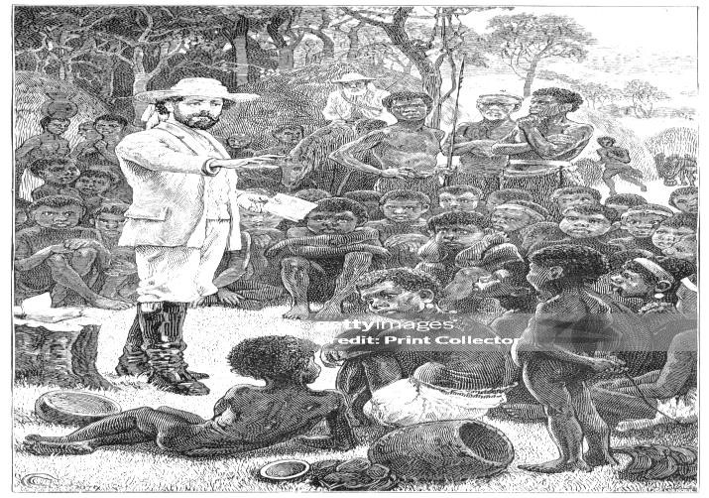A section of the people of Kalongo village are against activities of a Christian religious group from Germany. They petitioned the local government of the area to block its operations in their community citing challenges like noise pollution, fraud by pastors, and spread of gay-related activities among others. However, majority of the people in the area are of the view that despite the above challenges, religion plays a significant role in the development of the community as such, the Christian group should be left to carry out their activities.

**Task:**

Write an essay to convince the people in Kalongo to welcome the activities of the Christian group.

1. The need to be addressed in the scenario is that some community members of Kalongo want to block the activities of a Germany Christian group for the fear of the negative effects that come with new Christian groups.
2. This group is similar to the missionary groups that came to East Africa specifically Uganda. The protestant missionaries under the church missionary society led by Kraft and Rebmann and later the Catholics who comprised of the white feathers led by father Lourdel and Brother Ammans. So below are some of the ways the people of Kalongo shall benefit from accepting the activities of the whites from Germany.
3. By accepting activities of white missionaries, education of Kalongo will improve. They will construct primary, secondary and higher institutions of learning hence improving the economic situations and quality of life of Kalongo people.
4. By accepting their activities, the people of Kalongo village will get better healthcare. Clinics and hospitals will be constructed to combat water related diseases like dysentery, other diseases like malaria, typhoid among natives.
5. The orphans of Kalongo village are likely to be helped if the white missionaries are allowed to operate the area. Example, by providing them food and access to education.
6. Evangelism will be accelerated in Kalongo village if the white missionaries from Germany are allowed to operate. Christianity focusing on spreading the word of God and the gospel will be promoted among residents of Kalongo.
7. If the village accepts the missionary activities improved agricultural methods will be introduced among the locals. Example, agro -forestry, organic farming, vertical farming, drip irrigation which will increase crop yields, enhance food security at Kalongo.
8. Modern crops will be brought by the white missionary group from Germany to benefit the people of Kalongo. Example, cucumber, moringa, turmeric, ginger, avocados, garlic, sunflower among others. These crops can improve nutrition, food, security and income for Kalongo farmers.
9. The infrastructure of Kalongo village will be developed by the white missionaries from Germany if given a chance to operate. Example, building wells, hospitals, schools, roads, installing solar panels, better housing and shelter, latrines among others. This will lead to sustainable development of Kalongo village.
10. White German missionaries can bring modern technology based on European standards among the residents of Kalongo. Example, renewables energy, water purification, digital education, digital evangelism which will empower the community of Kalongo.
11. Kalongo community will be exposed to European cultures by the German missionaries. Example, Democratic practices, empathy and kindness, transparency and accountability, respect of environment, new sports and games, humility and servant leadership and others. This will promote cultural diversity and exchange among Kalongo natives.
12. Welcoming white missionaries from Kalongo will be better the architecture of the area by introducing eco-friendly materials like bamboo in construction, use of low carbon cement, container architecture, building structures that can be assembled and others. Hence sustainable development of the village.
13. Kalongo residents will be equipped with vocational skills and technical education through the white missionaries’ activities in the area. Example, computer skills, electrical work, plumbing, carpentry, construction and building skills, fashion and design, tailoring etc. this will empower Africans of Kalongo village with practical skills to improve their livelihoods.
14. More jobs/employment opportunities’ can be created in Kalongo village by the white missionary group from Germany. These Germans will train and employ, teachers, doctors, nurses, midwives, IT professionals, architects, builders, electricians, social workers, leaders among others. This will contribute to development of the village.
15. The natives of Kalongo will learn a number of European languages from the German missionary group. Example, English, French, Portuguese, Spanish, German, Italian, Dutch among others. This support education and communication as well as economic opportunities among the people of Kalongo.
16. **A viable conclusion, in line with the task.**
17. **Scoring grid**

|  |  |  |  |
| --- | --- | --- | --- |
| **Introduction** |  | Learner should be able to;  ➢ Identify a problem in the scenario (01score)  ➢ Give a relevant Introduction on the coming of missionaries in uganda(01score) | Maximum scores (2scores) |
| **Body** | The learner should  Explain the benefits of cultural institutions. | Learner should be able to:  explain (9-10) benefits (05scores)  Explain between 7-8Benefits (4scores)  Explains (5-6) benefits (03scores)  Explains (3-4)benefits (02score)  Explains (1-2) benefits (01score)  No response (00) | Maximum scores (05) scores |
| **conclusion** |  | Learner gives a relevant conclusion in line with the task. (01 score)  No conclusion (00 scores) | Maximum scores (01 score) |
| **Total scores** |  |  | (08 scores) |

**ITEM 2**

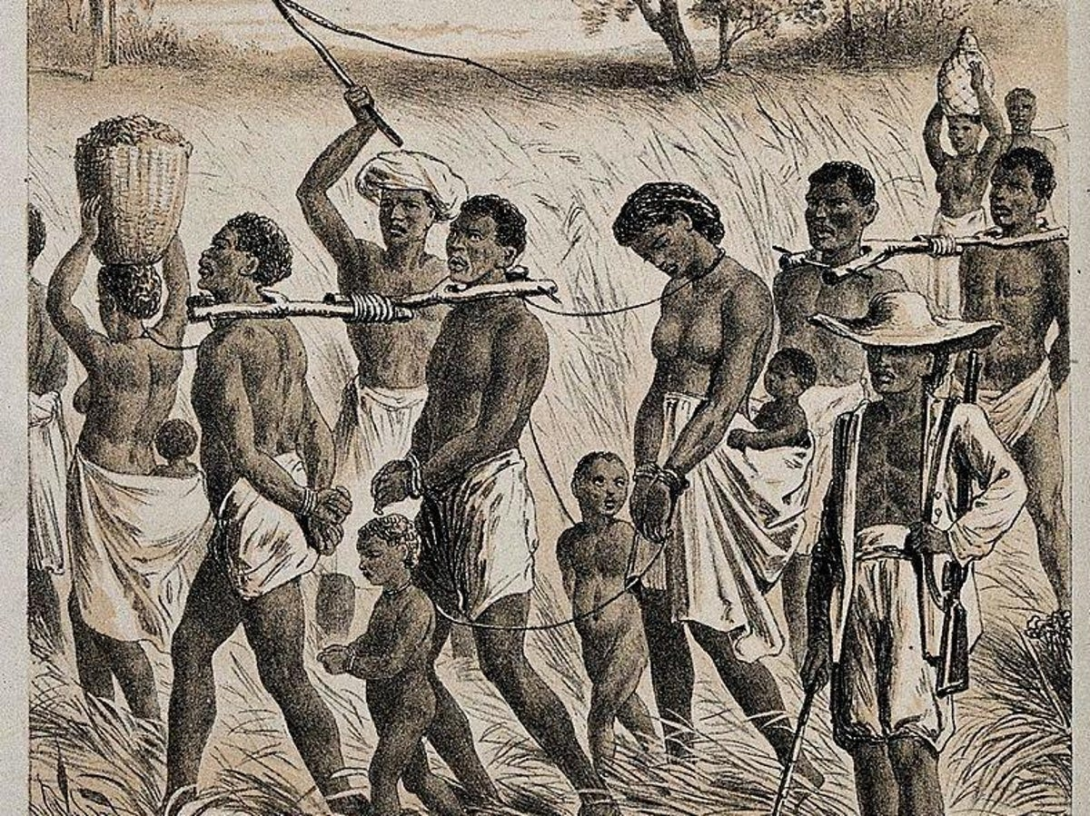During the history lesson in S.2 class, an argument broke out regarding the influence of slave trade in east Africa during the 19th Century. Some learners argued that the activity was entirely negative to the people of East Africa, while some mentioned that it was beneficial to some communities despite its negative effects. You have been invited to talk to the S.2 class about the topic in question.

**Task**

Make a write up that you will use when talking to the class.

1. S2 students lack adequate knowledge about the impact of slave trade as such they have fallen into an argument.
2. Slave trade was the buying and selling of humans conducted in the interior and at the coast of east Africa.

**Positive contributions of slave trade;**

* It strengthened the large and powerful states especially those with access to guns at the expense of small ones like Buganda.
* Chiefs like Mirambo became rich and built a strong empire using wealth from the trade.
* Some tribes like the Yao made it a mode of survival due to their active participation in the trade.
* Kiswahili language and culture spread in east Africa by the Swahili traders that moved into the interior of east Africa.
* The slave trade in East Africa led to the introduction of new crops like rice and wheat.
* Plantation flourished around slave trading centers where the traders settled.
* Slave routes later became major roads, railway lines and major highways.
* Slave collecting centers like Tabora, Ujiji later grew into big towns
* Later Christianity spread to many parts of east Africa because it preached against slavery.

**Negative effects of slave trade**

* Slave trade led to increased wars in east Africa because of the increase in raids
* Crops were burnt and people deserted their farmlands leading to famine.
* The slave trade led to massive destruction of property in East Africa.
* Traditional industry and crafts declined due to the slave trade.
* Political development was retarded because those who would have been leaders were either killed or enslaved.
* Those who had engaged in the trade became jobless when it was stopped.
* The trade led to detribalization of the societies of east Africa due to inter-tribal wars.
* Slave trade led to loss of lives of so many people due to slave raids.
* The slave Traditional rulers who practiced the trade were hated and mistrusted by the local people because they were considered agents of the slave traders.

**Scoring grid**

|  |  |  |  |
| --- | --- | --- | --- |
| **Introduction** |  | Learner should be able to;  ➢ Identify a problem in the scenario (01score)  ➢ Give a relevant Introduction on the coming of religion in Uganda (01score) | Maximum scores (2scores) |
| **Body** | The learner should  Explain the benefits of religion. | Learner should be able to:  explain (10-12) positive and negative effects of slave trade (05scores)  explain (7-9) positive and negative effects of slave trade (04scores)  explain (5-8) positive and negative effects of slave trade (03scores)  explain (1-) positive and negative effects of slave trade (02scores)  No response (00) | Maximum scores (05) scores |
| **conclusion** |  | Learner gives a relevant conclusion in line with the task. (01 score)  No conclusion (00 scores) | Maximum scores (01 score) |
| **Total scores** |  |  | (08 scores) |

**Item 3**

For over three decades, a number of people have moved to Uganda called migrants settling in different parts of the country including your community. Their coming has largely led to conflicts with the local people in the area they have settled. The local leaders of these areas have identified you to work with them to resolve this conflicts and encourage the natives to accommodate them.

**Task**

As a student of history and political education, write an essay explaining the effects of the migrants to the people of Uganda and give a resolution of what could be done to avoid this.

**KIYALA HIGH SCHOOL**

**S.3 THRID TERM TEST**

**ITEM 1**

In areas of Kasese in Uganda, river Nyamwamba flooded and a lot of property was destroyed including houses, gardens, small scale industries while many of the people surrounding the river were left dead. A few who survived were relocated to neighboring districts. The children of those who died are cautiously asking themselves many questions regarding the origins of their parents and relatives and have failed to get clear responses.

**Task:**

Explain to the above children the steps they should follow to achieve their desires.

**Expected responses;**

**Introduction**

1. The item taker should identify the problem in the scenario which is failure by a group of children to trace the origins of their parents and relatives who died and others displaced by the flooding of River Nyamwamba.
2. Therefore, there is need to suggest the steps / methods / techniques that these children can employ to trace origin of their parents and relatives by using **sources of history** which among others may include;

**Body**

* Oral tradition: Here, these children can ask several people surrounding them to narrate to them about the origin of their parents and relatives.
* Linguistics study: They can also study the language commonalities regarding dialects, accents, etc.
* Genetics: The children can use the modern science to compare genes of the people were their ancestors first lived.
* Anthropology: This can also help these children to study and compare the ways of life of the people they came with to the new area and those they found where they settled.
* Written records regarding the areas where they came from can help these children in form of articles, books and other written information.
* Archaeology: They can also dig underground and study the remains to get the historical information.
* A viable conclusion is required.

**Scoring grid**

|  |  |  |  |
| --- | --- | --- | --- |
| **Introduction** |  | Learner should be able to;  ➢ Identify a problem in the scenario (01score)  ➢ Give a relevant Introduction (01score) | Maximum scores (2scores) |
| **Body** | The learner should  Explain the techniques that these children can employ to trace origin of their parents and relatives. | Learner should be able to:  Explains (5-6) strategies (04scores)  Explains (3-4) strategies (03score)  Explains (1-2) strategies (02score)  No response (00) | Maximum scores (04) scores |
| **conclusion** |  | Learner gives a relevant conclusion in line with the task. (01 score)  No conclusion (00 scores) | Maximum scores (01score) |
| **Total scores** |  |  | (**7**scores) |

**ITEM 2**

In Kilembe district, a group of foreign migrants settled in the area and took up the leadership of this district; they subjected the natives to unjust treatment which led them to untold misery and suffering. The natives would like to regain their independence as it is the only way this unfairness can be solved. You have been identified to educate these natives.

**Task:**

Explain ways how they can restore their status.

**Expected responses:**

**Introduction**

1. The item taker should identify the problem in the scenario which is foreign rule / colonialism and its negativity in East Africa. This is evidenced by the influx of foreigners in Kilembe district where they settled, imposed themselves as leaders and subjected the natives to unjust treatment.
2. Therefore, there is need to sensitize the natives of Kilembe district about the methods / steps that can be undertaken to end this foreign control and restore their independence.
3. Independence which is the state of being free external control which east Africa started on after 1945 with several nationalists joining the campaign to restore independence.

**Body**

* To restore their status and gain independence, the natives of Kilembe district can take up the following steps;
* They should unite and co-operate together in this struggle and denounce any form of sectarianism e.g. tribalism and ethnicity.
* Form a united front to demand for their rights and freedom.
* Adopt militarism by staging violent resistances against these foreign migrants.
* Borrow examples from successful liberation struggles in Africa e.g. the defeat of Apartheid in South Africa.
* They must acquire the knowledge and skills to compete with the immigrants and assert their rights.
* They should adopt non-violent resistance strategies such as peaceful protests, boycotts and civil disobedience to put pressure on the immigrants to lose their grip on power.
* The people of Kilembe should reach out to local and international organizations, government and human rights groups to raise awareness and get support for their cause.
* They should identify and develop capable leaders from within the native community to spearhead the movement and issues peacefully such as negotiations, mediation to address their grievances.
* They should develop economic independence by supporting local business, initiatives to reduce reliance on immigrants.
* They should demand for political representation in local governance and political structures to ensure their voices are heard and interests represented. The natives must remain committed to their cause and continue to push it.
* **A viable conclusion is required.**

**Scoring grid**

|  |  |  |  |
| --- | --- | --- | --- |
| **Introduction** |  | Learner should be able to;  ➢ Identify a problem in the scenario (01score)  ➢ Give a relevant Introduction (01score) | Maximum scores (2scores) |
| **Body** | The learner should  Explain the strategies that can be adapted to restore the independence of the people of Kilembe. | Learner should be able to:  explain (8-10) strategies (05scores)  Explain between (6-7) strategies (4scores)  Explains (4-5) strategies (03scores)  Explains (2-3) strategies (02score)  No response (00) | Maximum scores (05) scores |
| **conclusion** |  | Learner gives a relevant conclusion in line with the task. (01 score)  No conclusion (00 scores) | Maximum scores (01score) |
| **Total scores** |  |  | (**8**scores) |

**Item 3**

The constitution of Uganda of 1997 allowed the central government to decentralize its powers to the local government. Today the local government is operating in the different districts all over the country. A number of challenges e.g. limited funds; corruption, delay of payments, lack of materials, etc have hindered their work.

**Task:**

What should be done to address the above challenges?

The learner should identify the problem in the scenario which is challenges faced by local government.

1. The learner should also define local governments the body that has a responsibility of administering a smaller geographical area on behalf of the central government. Such areas include, a village, ward, municipal council, district, city etc.

The problems faced by these governments can be handled / solved in the following ways.

* Training / skilling of local government officials through capacity building workshops and seminars.
* Increase the tax base in low governments.
* Proper accountability and management of funds.
* Central government should release funds on time to enable smooth running of the activities of local government.
* Limit interference with affairs of government.
* Encourage citizen participation in the local government.
* Sensitize public on purpose of local government. Improving service delivery to gain mass support.
* Setting up strict laws against corruption.
* Central government should increase funding / funds allocated to local government.
* Encourage whistle blowing on cases of corruption.
* Refresher course of local government staff.
* Increasing on their salaries to avoid temptations.
* Strengthening of office of IGG in full.
* Encouraging public disposal of public assets.

**Scoring grid**

|  |  |  |  |
| --- | --- | --- | --- |
| **Introduction** |  | Learner should be able to;  ➢ Identify a problem in the scenario (01score)  ➢ Give a relevant Introduction (01score) | Maximum scores (2scores) |
| **Body** | The learner should  Explain the solutions challenges faced by local government. | Learner should be able to:  explain (8-10) solutions (05scores)  Explain between (6-7) solutions (4scores)  Explains (4-5) constitutional right solutions (03scores)  Explains (2-3) solutions (02score)  No response (00) | Maximum scores (05) scores |
| **conclusion** |  | Learner gives a relevant conclusion in line with the task. (01 score)  No conclusion (00 scores) | Maximum scores (01score) |
| **Total scores** |  |  | (**8**scores) |

**Item 4**

In Uganda, a recent survey revealed a significant lack of awareness among citizens about their constitutional rights, especially in preparation for the upcoming general elections. In response, a dedicated group of educators is organizing a nation-wide awareness campaign. This campaign aims to empower individuals by increasing their understanding of constitutional rights, and you have been tasked with participating in this important initiative.

**Task:**

**Write an essay with key aspects to educate the people in the above nation-wide campaigns.**

**Expected responses for item 4.**

**Introduction;**

Identify the problem in the scenario; Lack of awareness among citizens about their constitutional rights

Constitutional rights are individual freedoms and protections guaranteed by the country’s constitution, which is the supreme law of the land.

These rights are inherent to all citizens and are designed to protect individual liberties, promote social justice and limit government power.

**Body**

1. Freedom of speech and expression (Article 29
2. Right to privacy (Article 27)
3. Freedom from discrimination Article 21
4. Right to fair trial and due process (Article28
5. Right to freedom of religion and conscience (Article 29)
6. Freedom of assembly and association (Article 30)
7. Right to vote and participate in democracy
8. Freedom from torture and cruel treatment 24
9. Right to life, Article22
10. Right to liberty and security of person Article 23
11. Right to equality 21
12. Right to movement and residence 31
13. Right to access information 41
14. Right to clean and healthy environment 39
15. Right to participate in cultural life 30
16. Right to access to justice 44
17. Right to education 30
18. Right to health 34
19. Right to work 32
20. Logical Conclusion

**Scoring grid**

|  |  |  |  |
| --- | --- | --- | --- |
| **Introduction** |  | Learner should be able to;  ➢ Identify a problem in the scenario (01score)  ➢ Give a relevant Introduction (01score) | Maximum scores (2scores) |
| **Body** | The learner should  Explain the constitutional rights | Learner should be able to:  explain (8-10) constitutional rights (05scores)  Explain between (6-7) constitutional rights (4scores)  Explains (4-5) constitutional rights (03scores)  Explains (2-3) constitutional rights (02score)  No response (00) | Maximum scores (05) scores |
| **conclusion** |  | Learner gives a relevant conclusion in line with the task. (01 score)  No conclusion (00 scores) | Maximum scores (01score) |
| **Total scores** |  |  | (**8**scores) |